Name – Vipul Viresh Patil

Nuid – 002833236

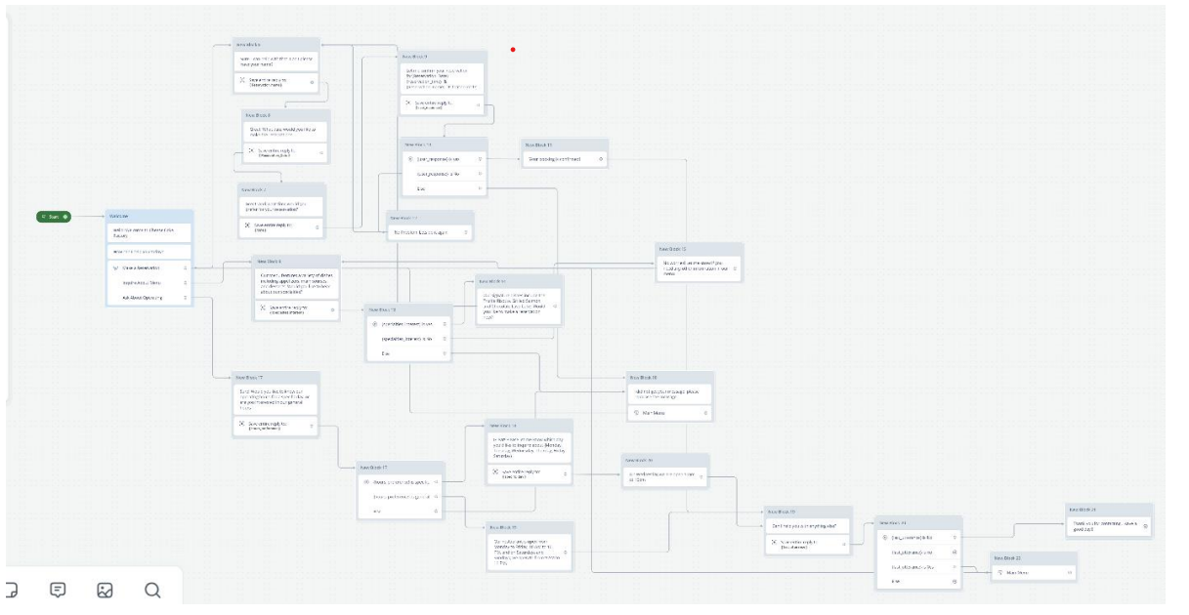

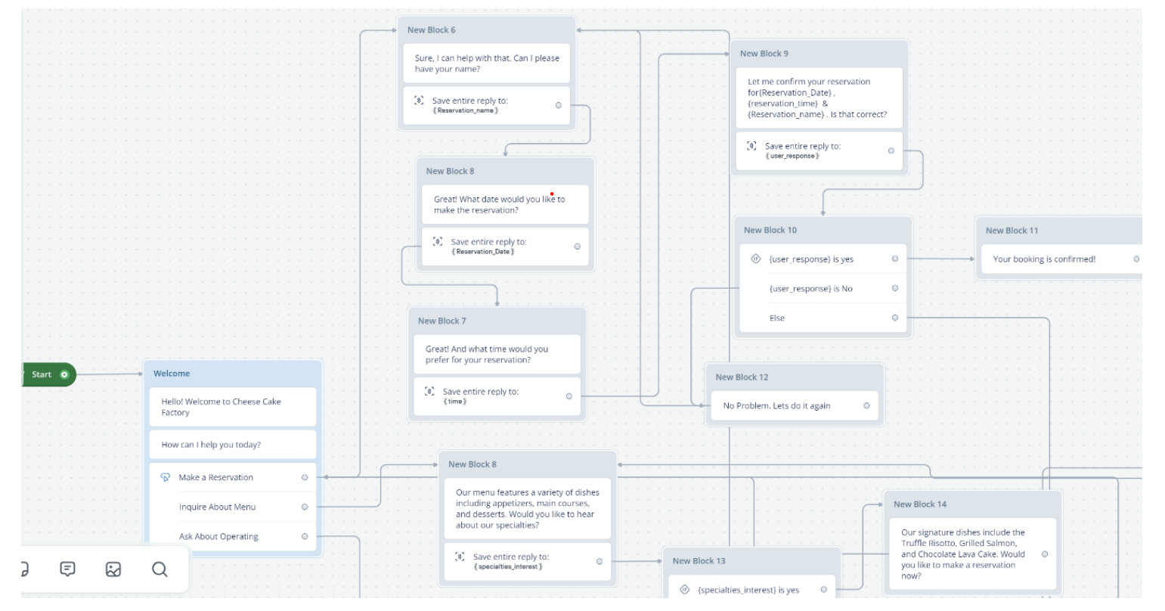

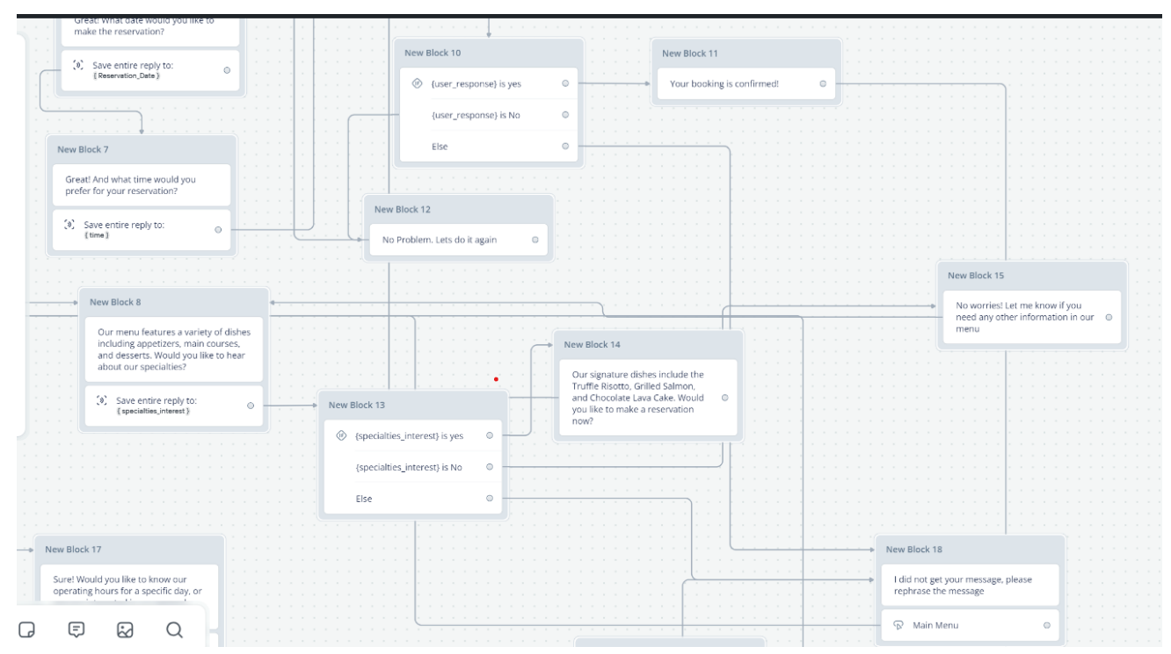

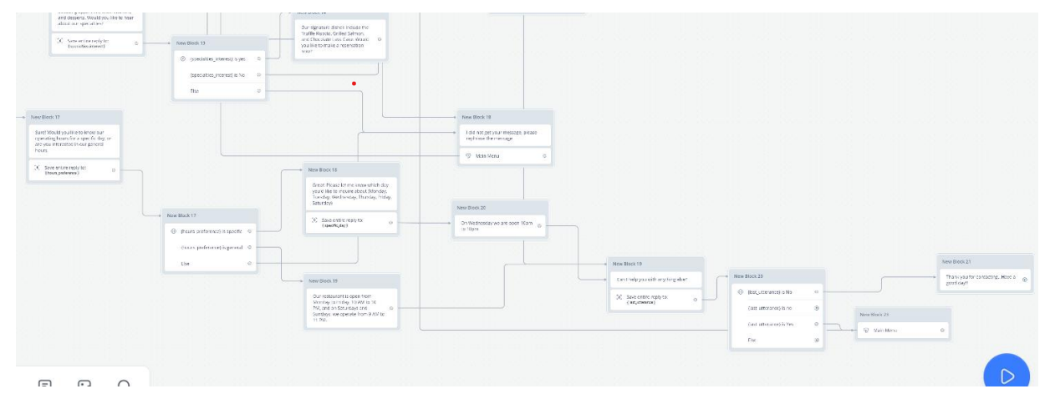

**Restaurant Reservation Assistant Bot: Operational Overview**

**Bot Conceptualization and Design Purpose**

The Restaurant Reservation Assistant is an intelligent conversational interface engineered to streamline customer interactions for restaurant services. Its primary objectives include facilitating restaurant reservations, providing menu insights, and addressing operating hours inquiries through sophisticated intent recognition mechanisms.

**Conversational Flow and Operational Logic**

**1. Initial User Engagement**

* Implement an inviting initial interaction that encourages users to articulate their specific service requirements
* Utilize advanced natural language processing to capture and interpret user intentions
* Store initial user input for subsequent intent classification

**2. Intent Classification Mechanism**

The bot employs a nuanced classification system to route user requests through distinct conversational pathways:

* **Reservation Pathway**: Activated by reservation-related terminology
* **Menu Information Pathway**: Triggered by culinary and menu-related queries
* **Operating Hours Pathway**: Responding to time and scheduling inquiries

**3. Contextual Response Strategies**

**Reservation Management**

* Systematically collect critical reservation details
* Prompt users for essential information sequentially
* Validate and confirm reservation parameters

**Menu Information Delivery**

* Provide comprehensive yet concise menu descriptions
* Highlight current specials or recommended dishes
* Offer clear, accessible culinary information

**Operating Hours Communication**

* Deliver precise timing information
* Accommodate potential variations in operating schedule
* Ensure clarity in communication of business hours

**4. Adaptive Interaction Management**

* Implement sophisticated fallback mechanisms for unrecognized user inputs
* Guide users constructively when intent cannot be immediately determined
* Maintain a user-friendly, helpful interaction model

**Technical Implementation Considerations**

The bot's architecture emphasizes:

* Flexible intent recognition
* Structured information collection
* Seamless user experience
* Adaptable response generation

**Operational Objectives**

The primary goal is to create an intuitive, efficient digital assistant that:

* Simplifies restaurant service interactions
* Provides immediate, accurate information
* Enhances customer engagement and satisfaction

**Conclusion**

By leveraging intelligent design and sophisticated language processing, the Restaurant Reservation Assistant transforms digital customer service interactions into streamlined, user-centric experiences.